***Champagne Louis Roederer Brut Rose***

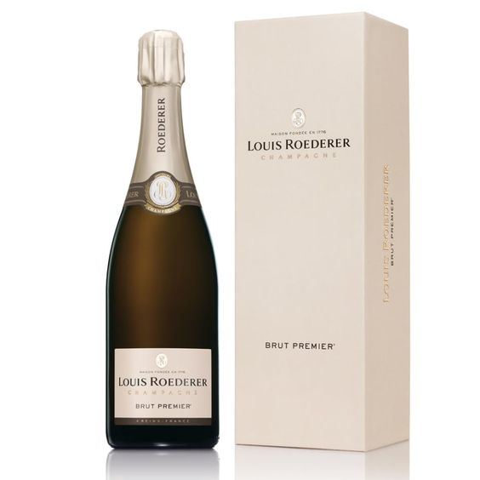

*Louis Roederer is a quite famous wine brand of the French region in general.*

*The birth of the producer has made a significant contribution to the history of the development of the country's winemaking industry. Because all the wines born here are very special and diverse, making the special in French wine unlike any other.  
  
This bottle of wine is typical of the producer. Matured by the perfect combination in certain proportions from the Chardonnay - Pinot Noir grape varieties, the wine contains rich and round aromas from these two grape varieties. In addition, the wine is also noted from many other ripe fruit aromas such as red berries, aromas from smoke and a hint of rose.  
  
A rather complex wine structure is contained in a glass bottle with pastel pink color, creating an extremely smooth and eye-catching external beauty. Moreover, with a gentle concentration of 12.5%, it ensures a smooth and smooth tannin content. In important parties such as entertaining partners or in luxury gift baskets, the presence of a bottle of wine is guaranteed to bring the best spiritual value.*